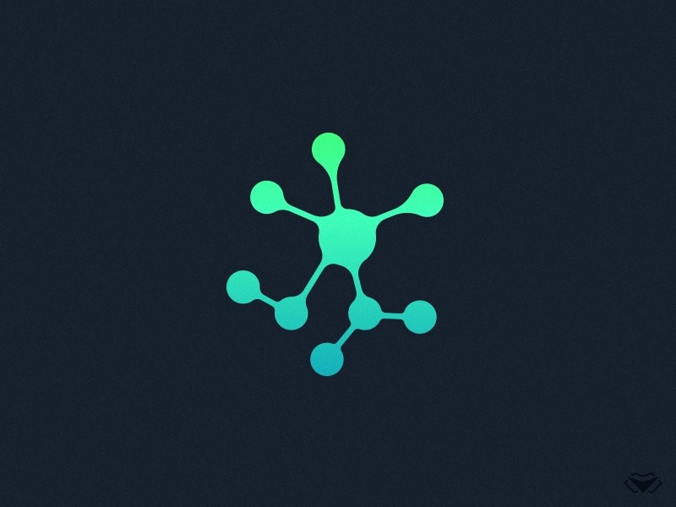

**TEAM 9 MEETING MINUTES**

**Meeting Details**

|  |  |
| --- | --- |
| **Team Name:** | Team 9 |
| **Meeting Date:** | 22nd September |
| **Time:** | 9:04AM - 10:00PM |
| **Venue:** | Faculty of Science Common Room |
| **Attendees:** | Issac, Matthew, Josh, Dhruv, Dennis |
| **Absent Members:** | Rodney |
| **Minutes Taker:** | Matthew |

**Agenda Details**

|  |  |
| --- | --- |
| Tasks | Sub-tasks |
| Discussions/Clarifications | * Sprint Deliverables * Scope of work |
| Next Meeting | * Talk over current project with Auditor * Report on any coding work done |

**Meeting Minutes with Client Starts**

* + Discussed current standpoint on project progress
  + Isaac presented current working model in unity
  + Client may bring someone with more knowledge on the potentials to provide assistance
  + Potential doing a calculation from distance
  + **Ray casts -** Client drawing a line from one point to another point. Gets the name and reference of every ____ that it collides with
  + Only works from going inside to outside (confirm)
  + May be a C# library for ray casts
  + Relevant periodic table data - Client
  + Matthew presented Blender Sandbox of the Lab
  + Client suggested that use lighting sparingly as lighting presents computational drain in unity
  + Add directional lighting
  + Real time of particles shadows
  + Have the time scales in the window and how many seconds have passed in the simulation (simulated seconds)
  + Suggestion to use thread pooling - Client
  + Use parallel for each loops
  + **Concurrent bag (list you can dump things, thread safe)**

CLIENT FINISH 9:30

POST-MEETING

**END 10:00am**